
Company
Logotype

Cone Beam Computed Tomography- Report



Porur Dental X-rays & CBCT

Patient Name : Mrs. Mangalambigai | Date of Report : 30.11.2024
Age/ Gender : 42 years/ Female | Region of Interest : CBCT Mandible
Referring doctor: Dr. M. Balamurali Sai | Indication : Implant assessment
Clinical Notes: Nil
PATIENT INFORMATION

CBCT- Mandible provided
CBCT – IMAGE DETAILS

RADIOGRAPHIC INTERPRETATION

- Completely missing crown and root portion in relation to 36, 38, 46, 48.
- Labially placed 33.
- The mandibular alveolar ridge is present with normal trabecular pattern.

 | 36 region | 46 region
Sub-Crestal (in mm) | 5.15 | 3.91
Mid- Crestal (in mm) | 7.16 | 7.38
Distance between alveolar ridge and the inferior alveolar nerve canal (in mm) | 12.19 | 12.42
Distance between alveolar ridge and the inferior border of mandible (in mm) | 20.59 | 20.25

IMPLANT ASSESSMENT

RADIOGRAPHIC IMPRESSION

- Partially edentulous mandibular alveolar ridge.

Kindly correlate with clinical findings


IMAGES FOR REFERENCE

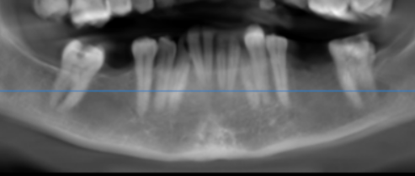
RECONSTRUCTED PANORAMIC VIEW

3-DIMENSIONAL VIEW

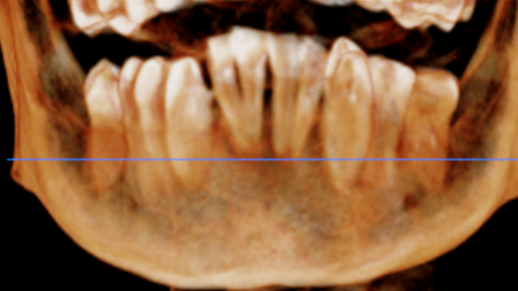

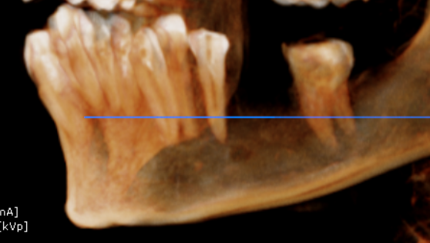
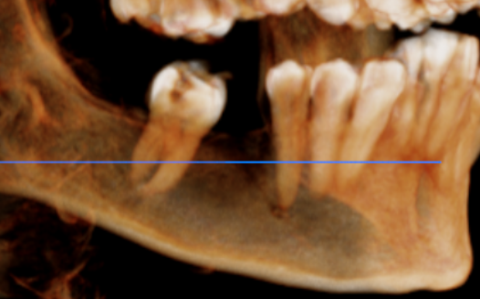

CROSS SECTIONAL VIEW

36 region | 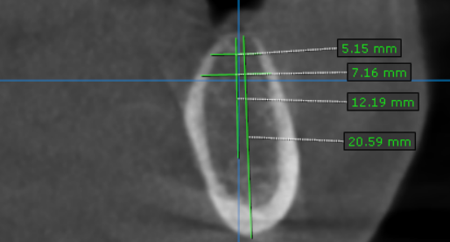
46 region | 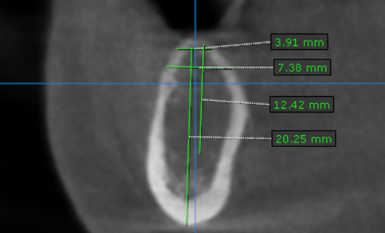

**** End of report ****

